Criterion C

Figma was used for interface wireframes, while Mermaid was used for architecture, database and algorithm diagrams.

0. System model

Component / Architecture Diagram

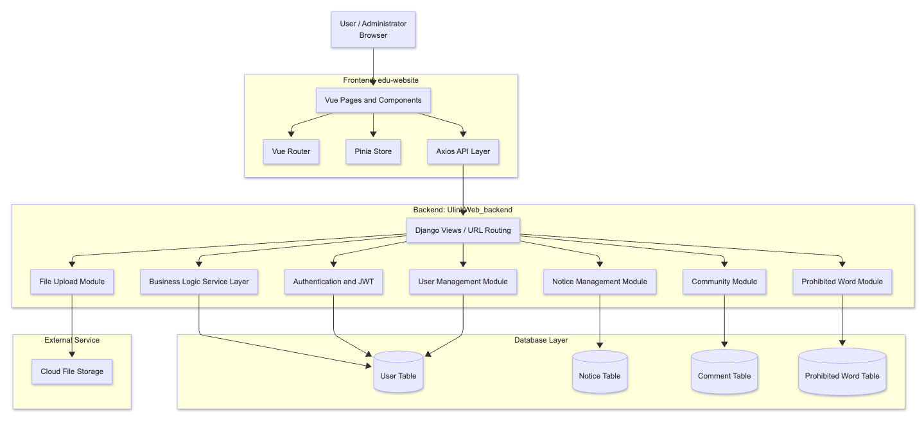
Fig. 0.1
Figure 0.1 shows a layered design: Vue handles presentation and client state, Axios sends API requests, Django applies authentication and business rules, and MySQL or cloud storage persists records and uploaded images.

DFD Level 0 (Context Diagram)
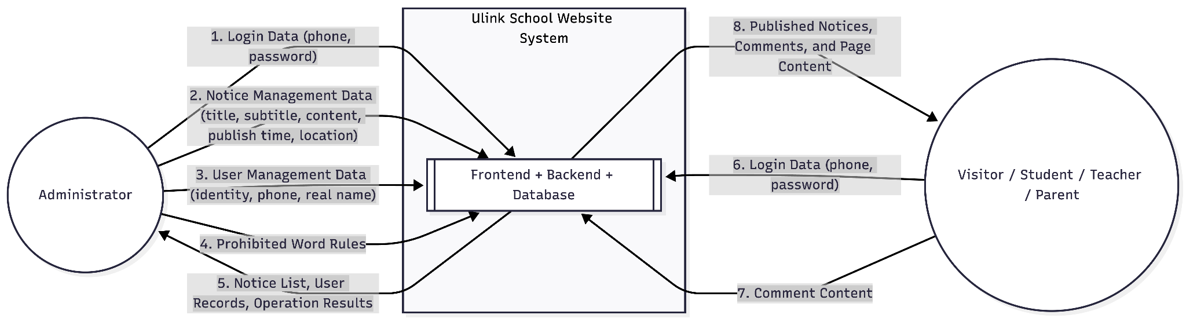

Fig. 0.2

UI Navigation Map
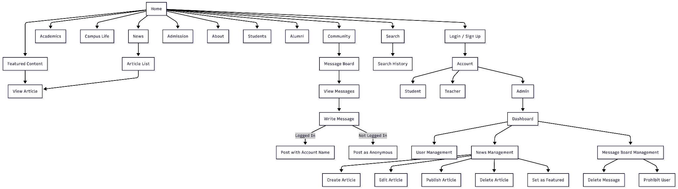
Fig. 0.3
Figures 0.2 and 0.3 define the data exchanged with administrators and public users, then separate public pages from authenticated community actions and role-restricted dashboard functions.

1. Database Schema

Table: admin_role_notice
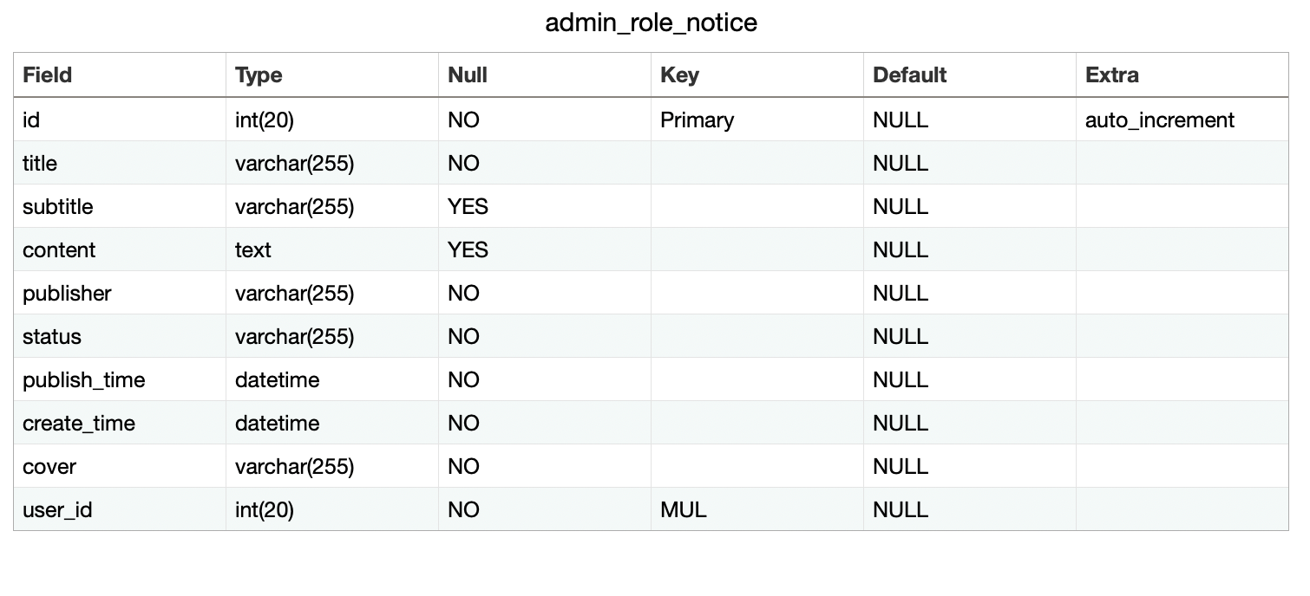
Fig. 1.1

Table: admin_notice_copy1
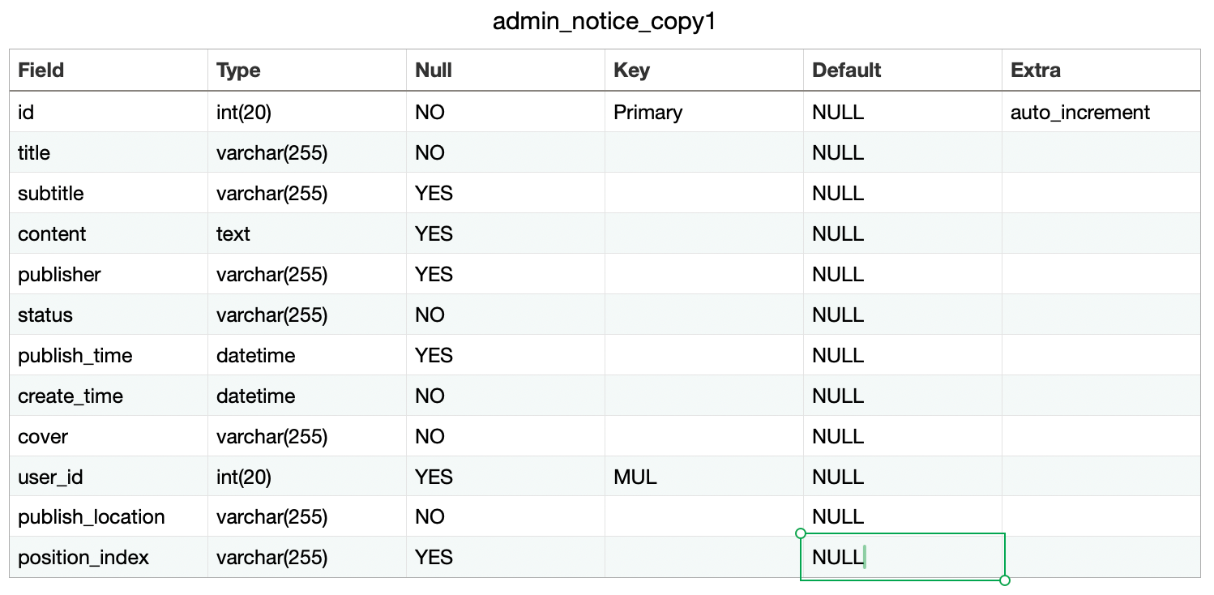
Fig. 1.2

Table: admin_role_admin
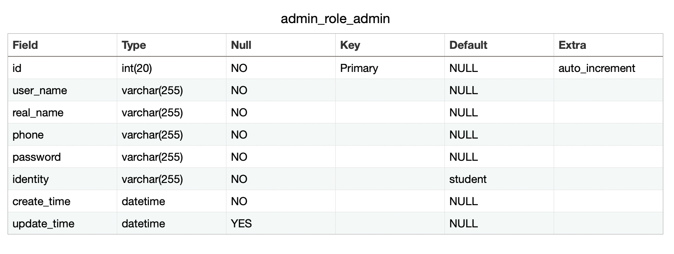
Fig. 1.3

Table: admin_role_teacher
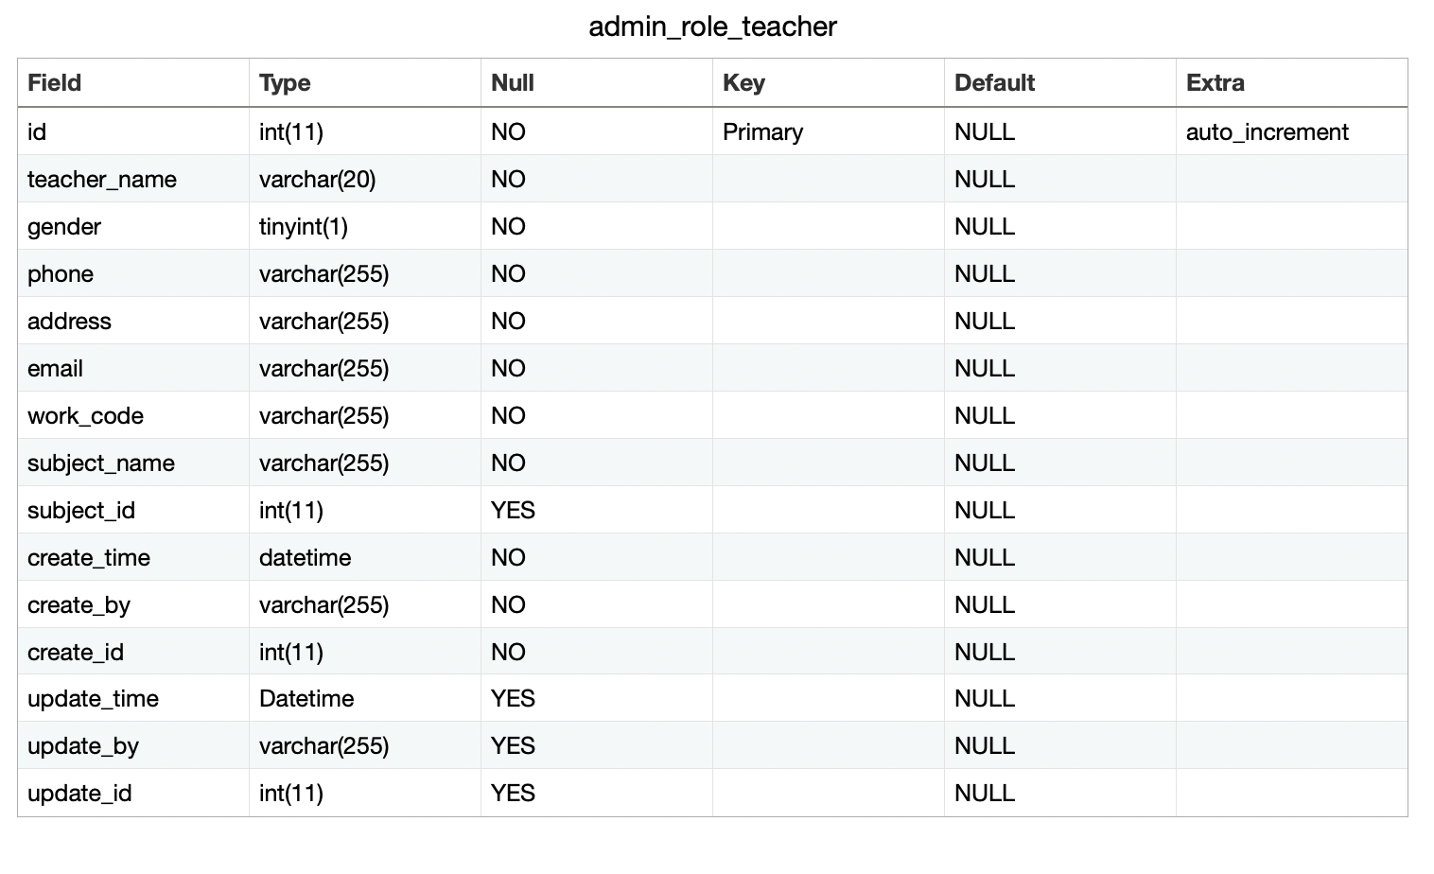
Fig. 1.4

Table: admin_role_students
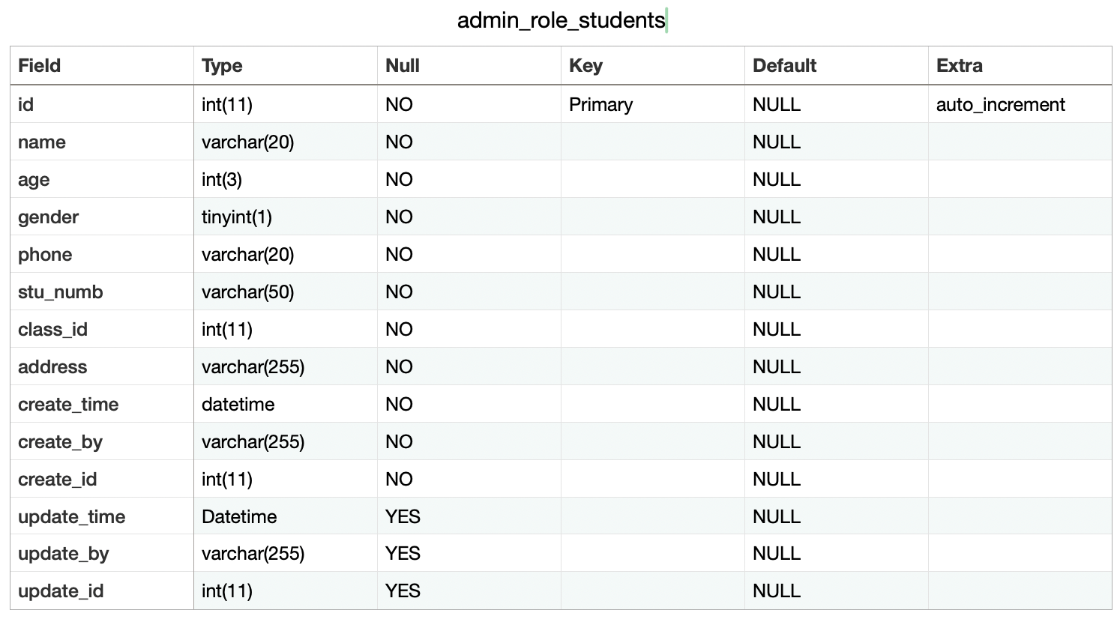
Fig. 1.5
Table: community_comment
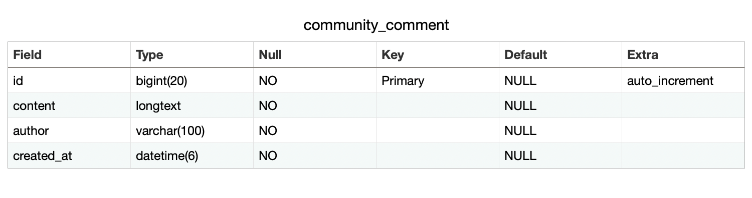
Fig. 1.6

ERD Diagram
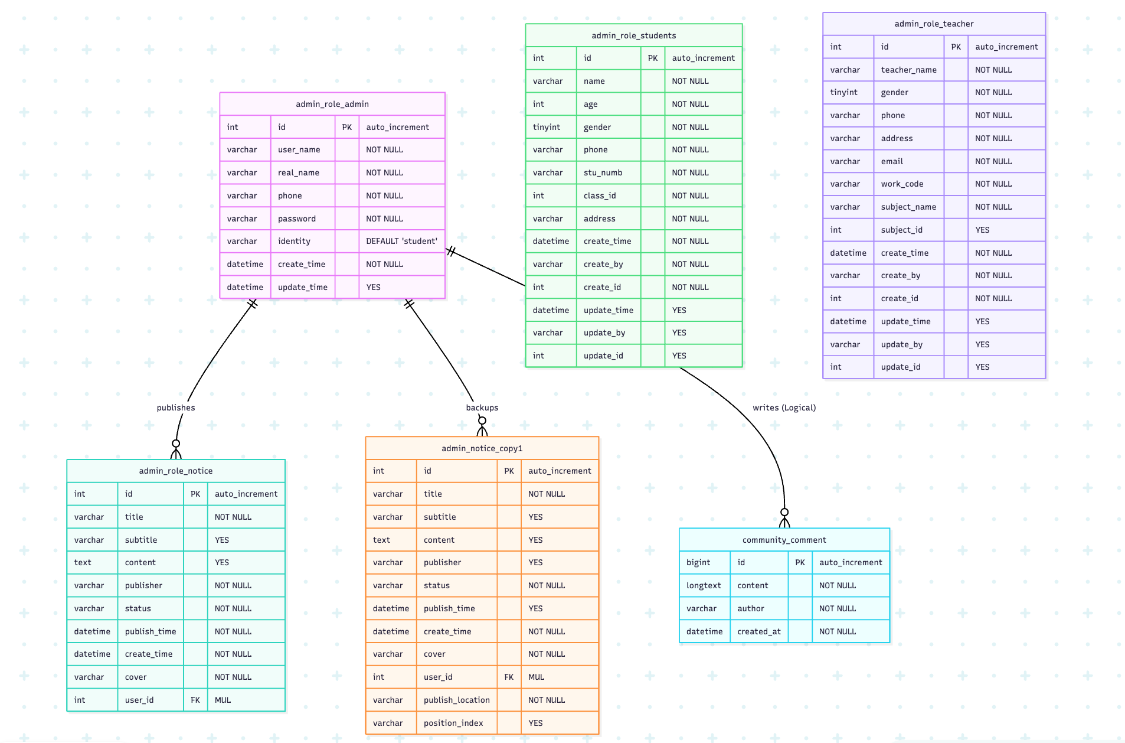

Fig. 1.7
Figure 1.7 shows the notice publishing and backup relationships. Comment authorship is logical because the authenticated display name is stored in the comment rather than through a physical foreign key.

2. The School Official Website consists of six main components:

1. Authentication & Role Module (Success Criterion 1)
- Wireframe of GUI: Login and registration forms collect phone, password and account details.
- Function Description: Compares the MD5-derived credential and issues a JWT containing the authenticated user's identity.
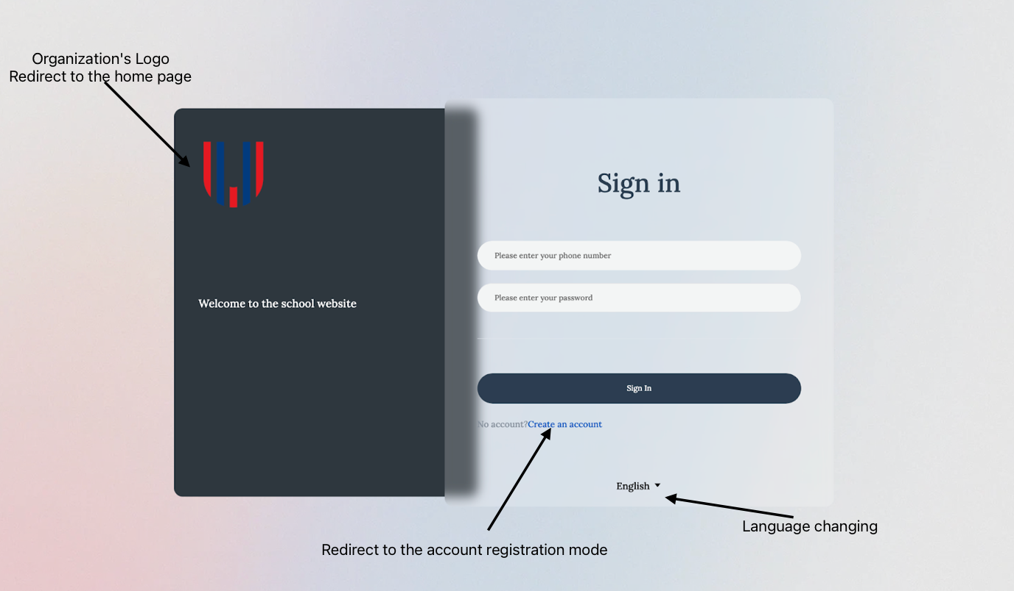
Fig. 2.1.1
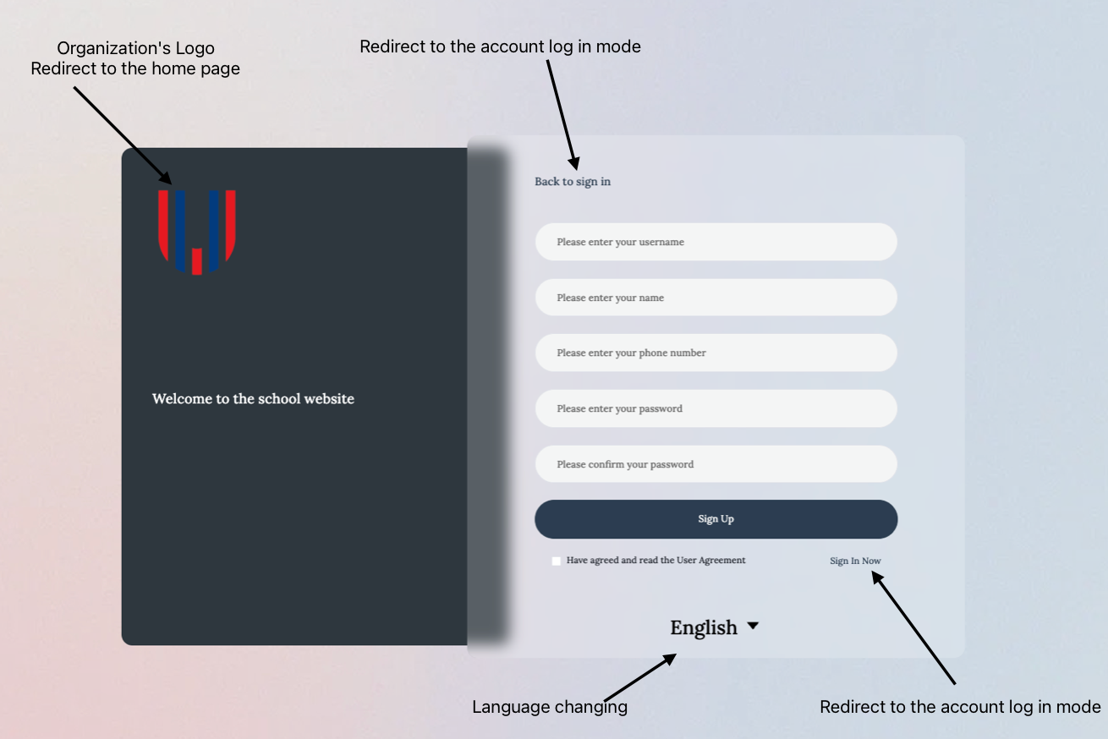
Fig. 2.1.2
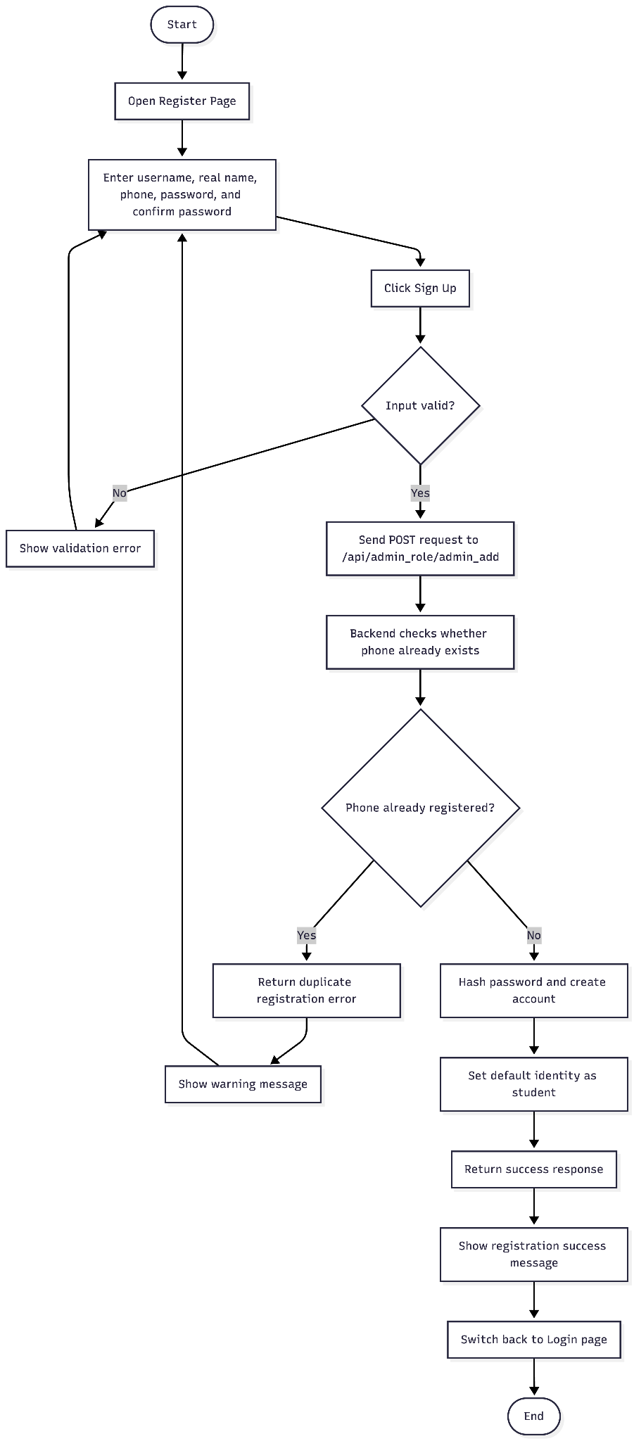
Fig. 2.1.3 Register

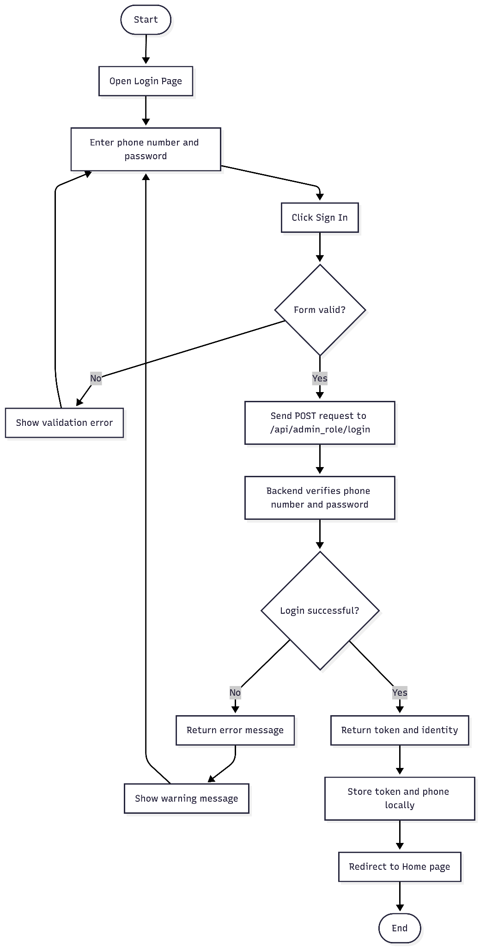
Fig. 2.1.4 Login

2. Notice Management Module (Success Criterion 2)
- Wireframe of GUI: Admin dashboard with "Create" button and "Edit/Delete/Withdraw" actions.
- Function Description: Provides full CRUD operations for school notices and allows manual status changes.
- Algorithm (Flowchart Logic): Input Notice Data -> Validate Permission -> SQL: UPDATE/INSERT Notice Table -> Return Success -> Update UI.
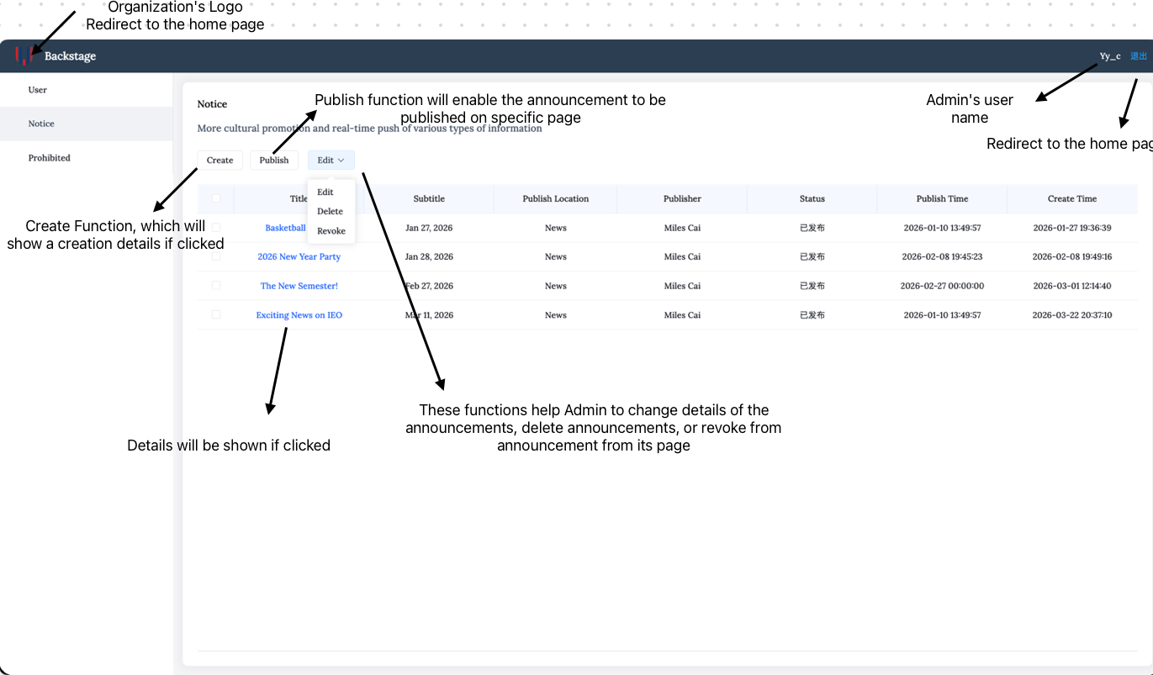
Fig. 2.2.1
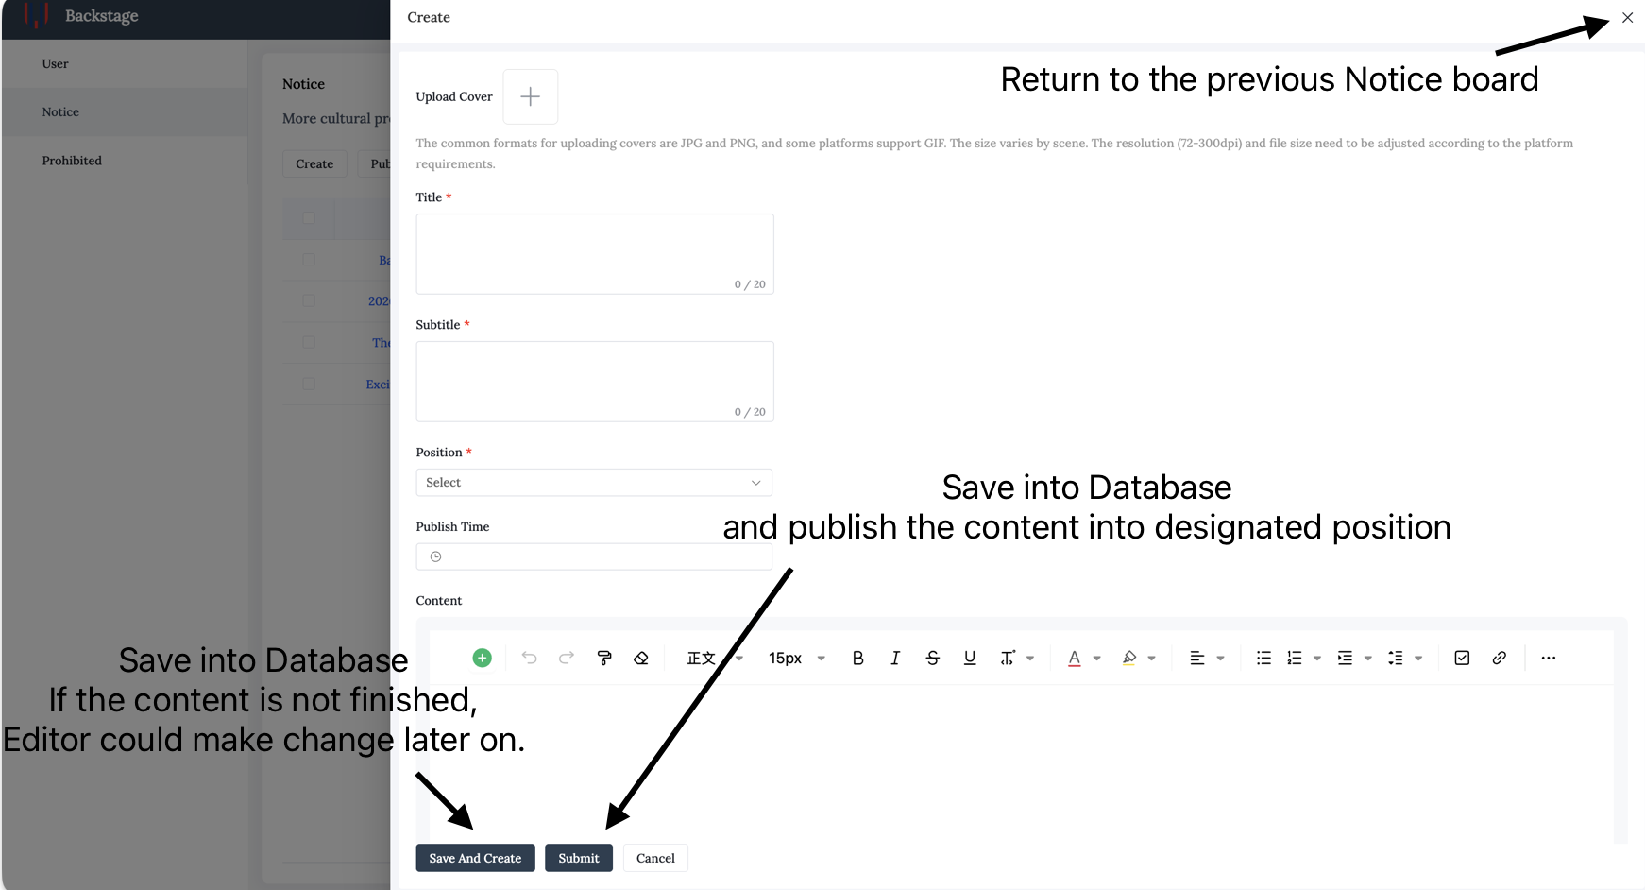
Fig. 2.2.2
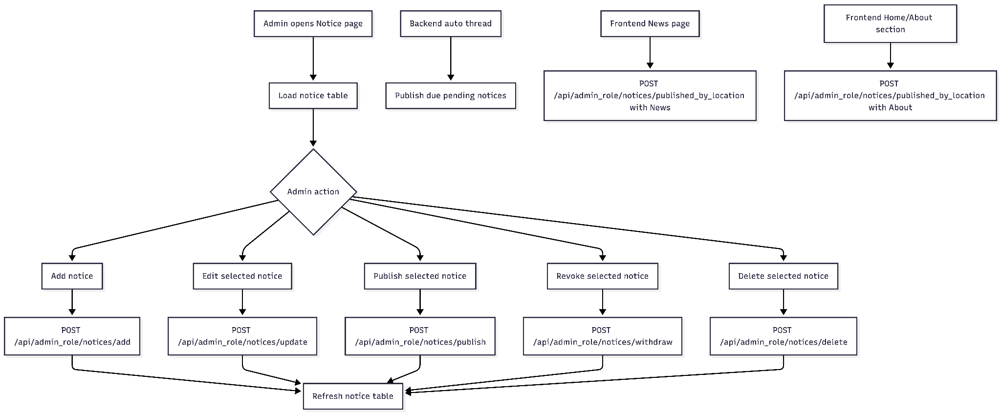
Fig. 2.2.3 Overall Module Structure

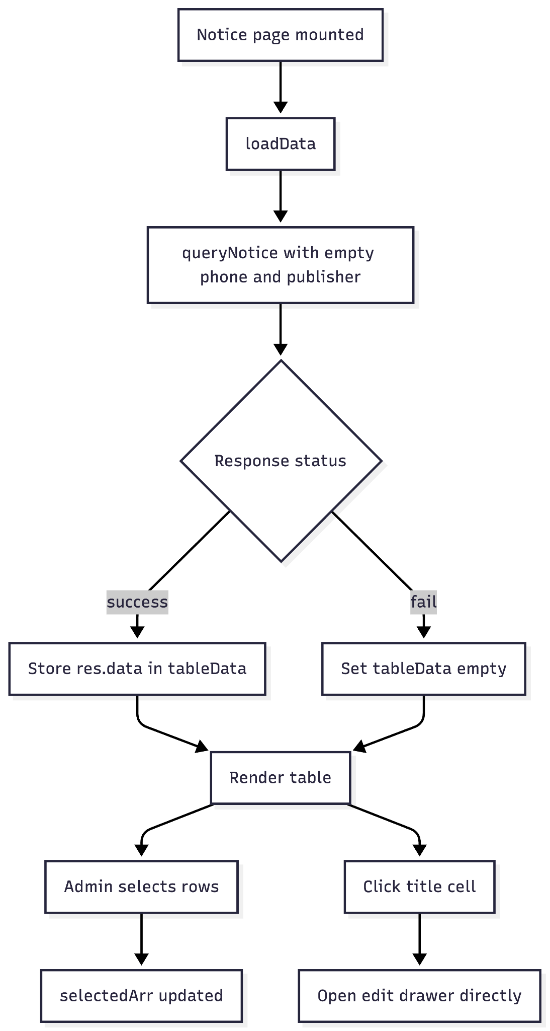
Fig. 2.2.4 Admin List And Select Notices
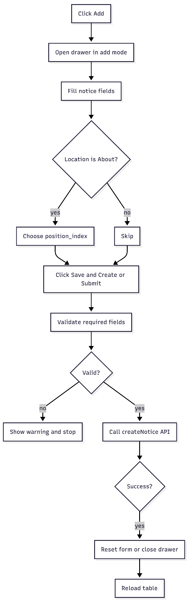
Fig. 2.2.5 Add Notice: Frontend Form
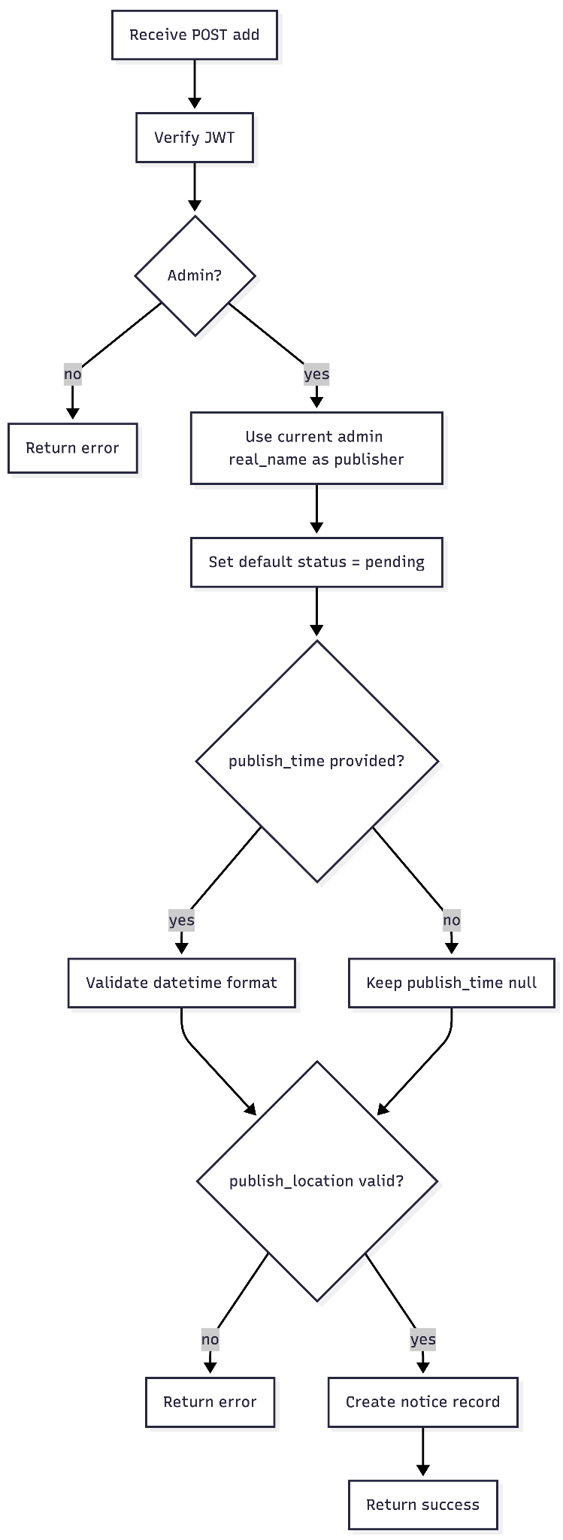
Fig. 2.2.6 Add Notice: Backend Creation

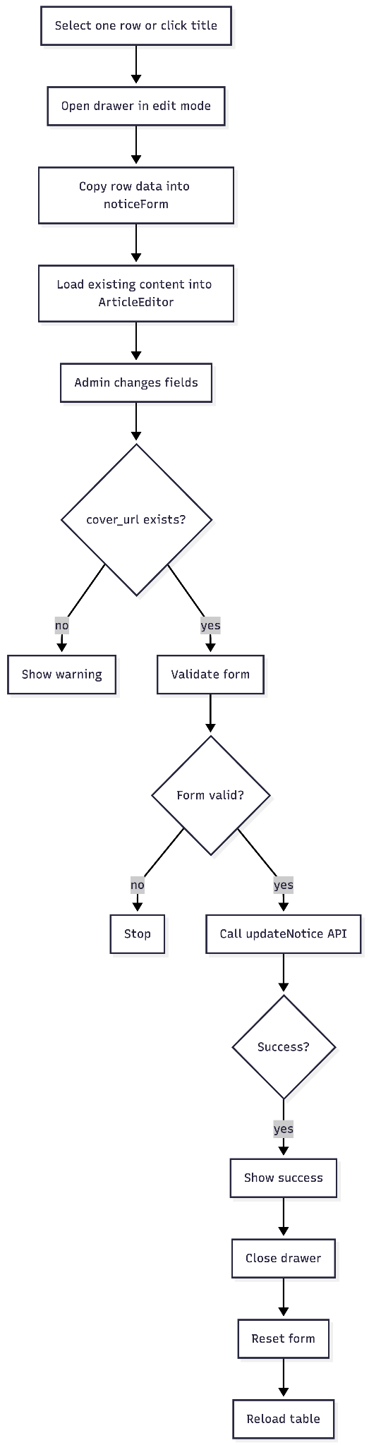
Fig. 2.2.7 Edit Notice: Frontend Submit
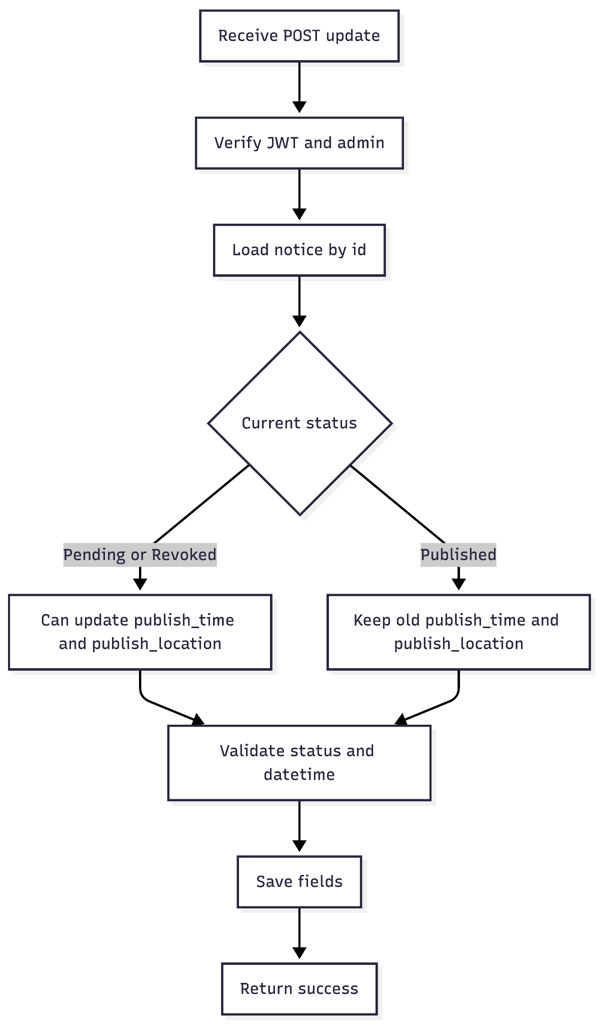
Fig. 2.2.8 Edit Notice: Backend Status Rules
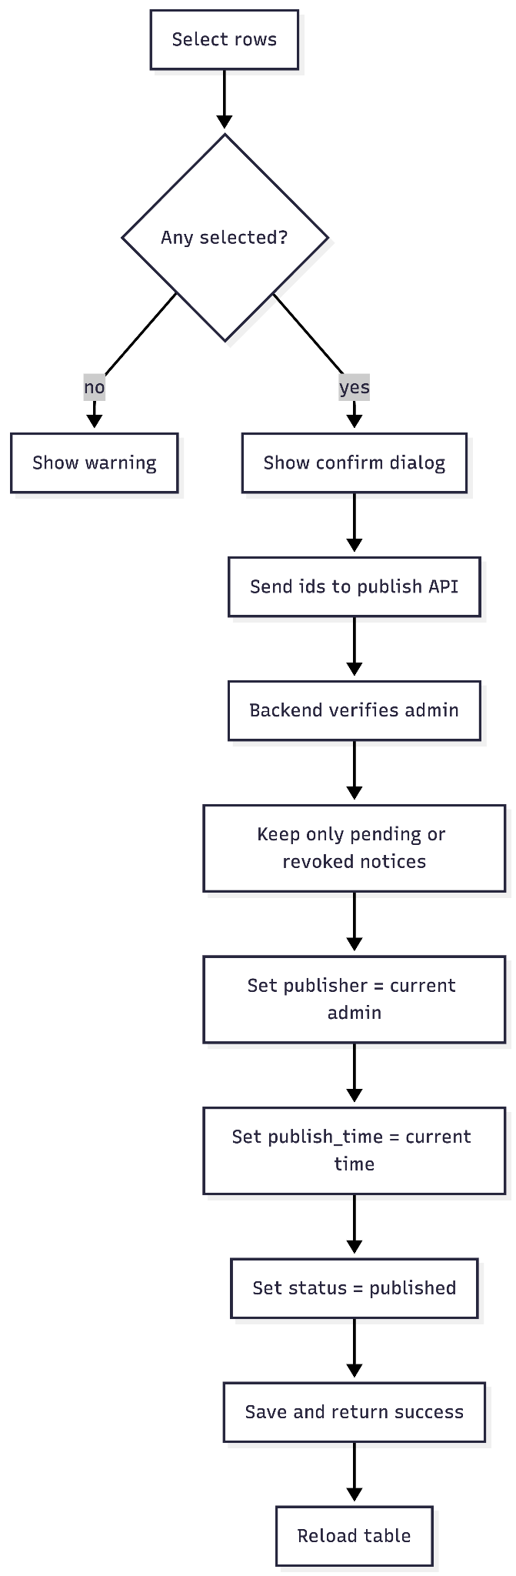
Fig. 2.2.9 Publish Notice
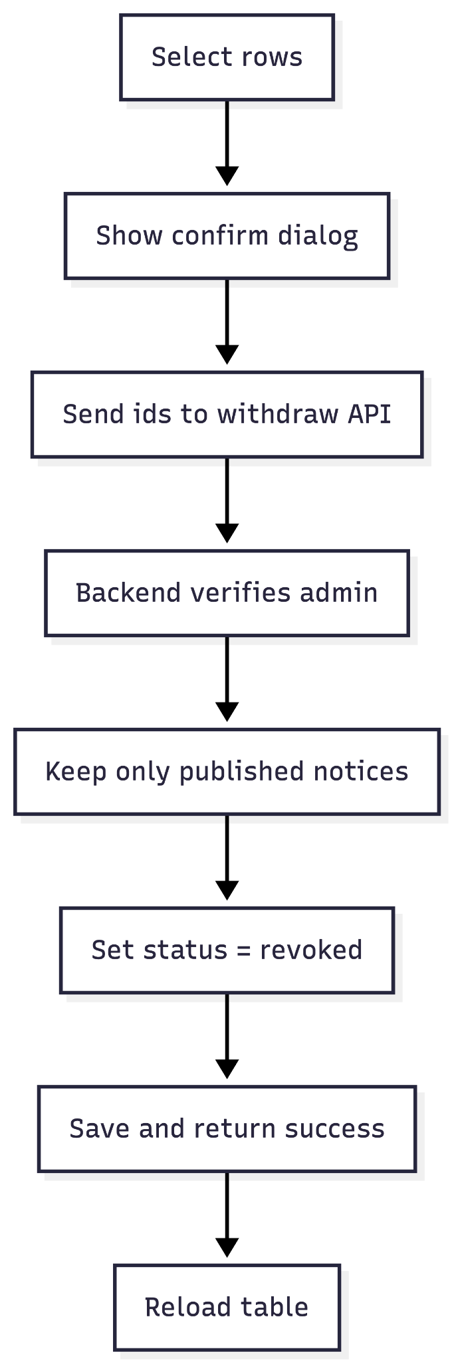
Fig. 2.2.10 Revoke Notice
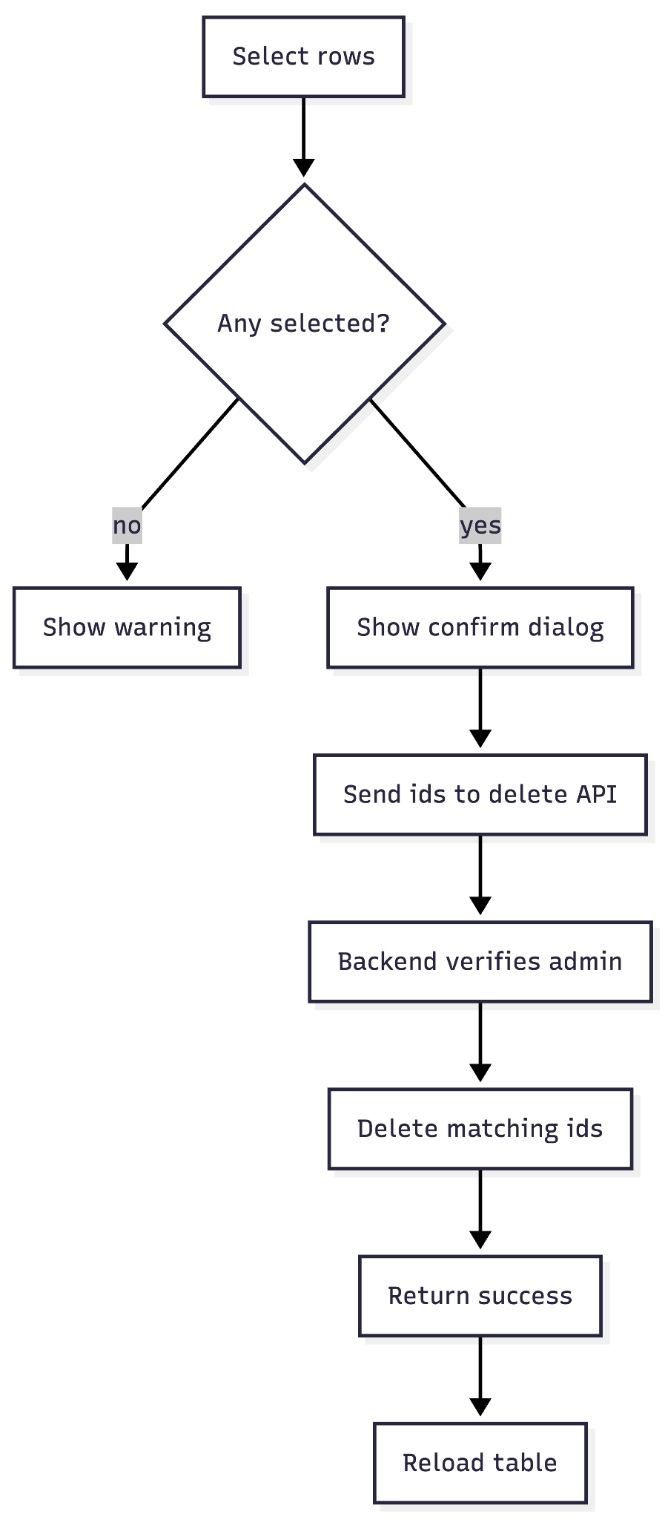
Fig. 2.2.11 Delete Notice

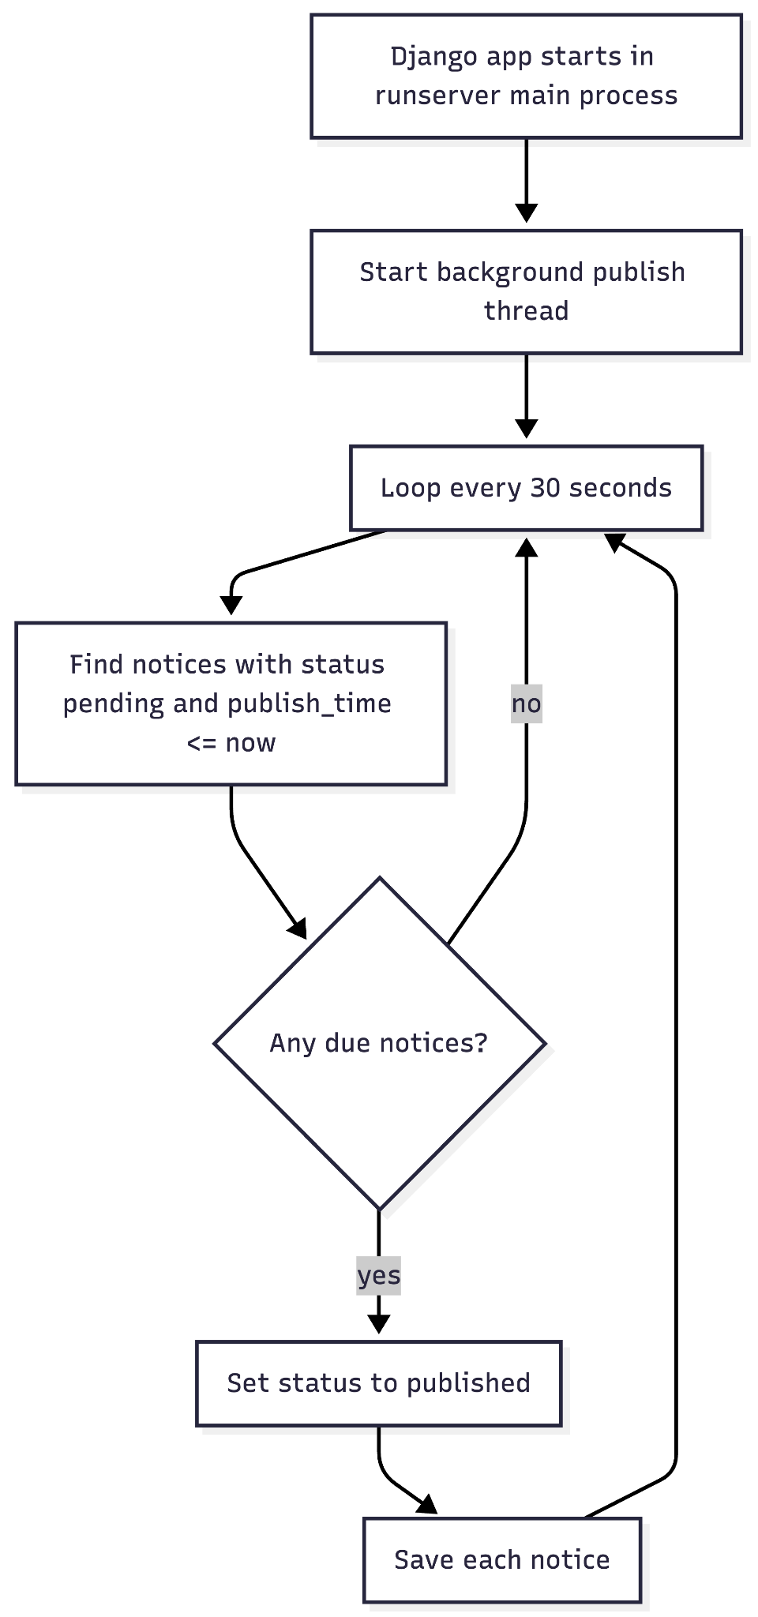

Fig. 2.2.12 Backend Auto-Publish Flow

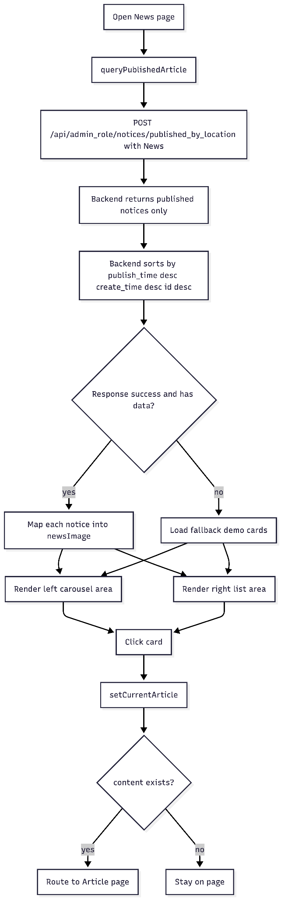
Fig. 2.2.13 Frontend News Page Rendering
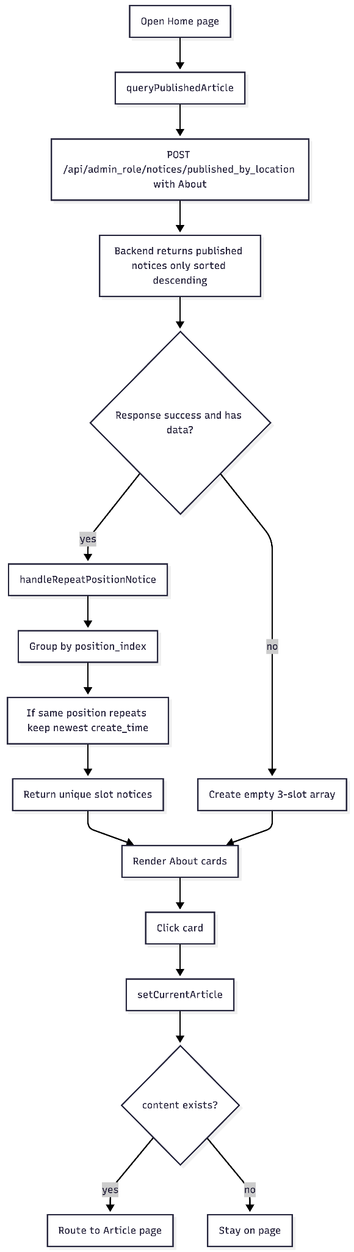

Fig. 2.2.14 Frontend About Page Slot Rendering

3. Automated Publishing Module (Success Criteria 2 and 3)
- Wireframe of GUI: Date-picker on the edit page for "Scheduled Publish Time".
- Function Description: A background thread changes pending notices to published when their scheduled time is reached.

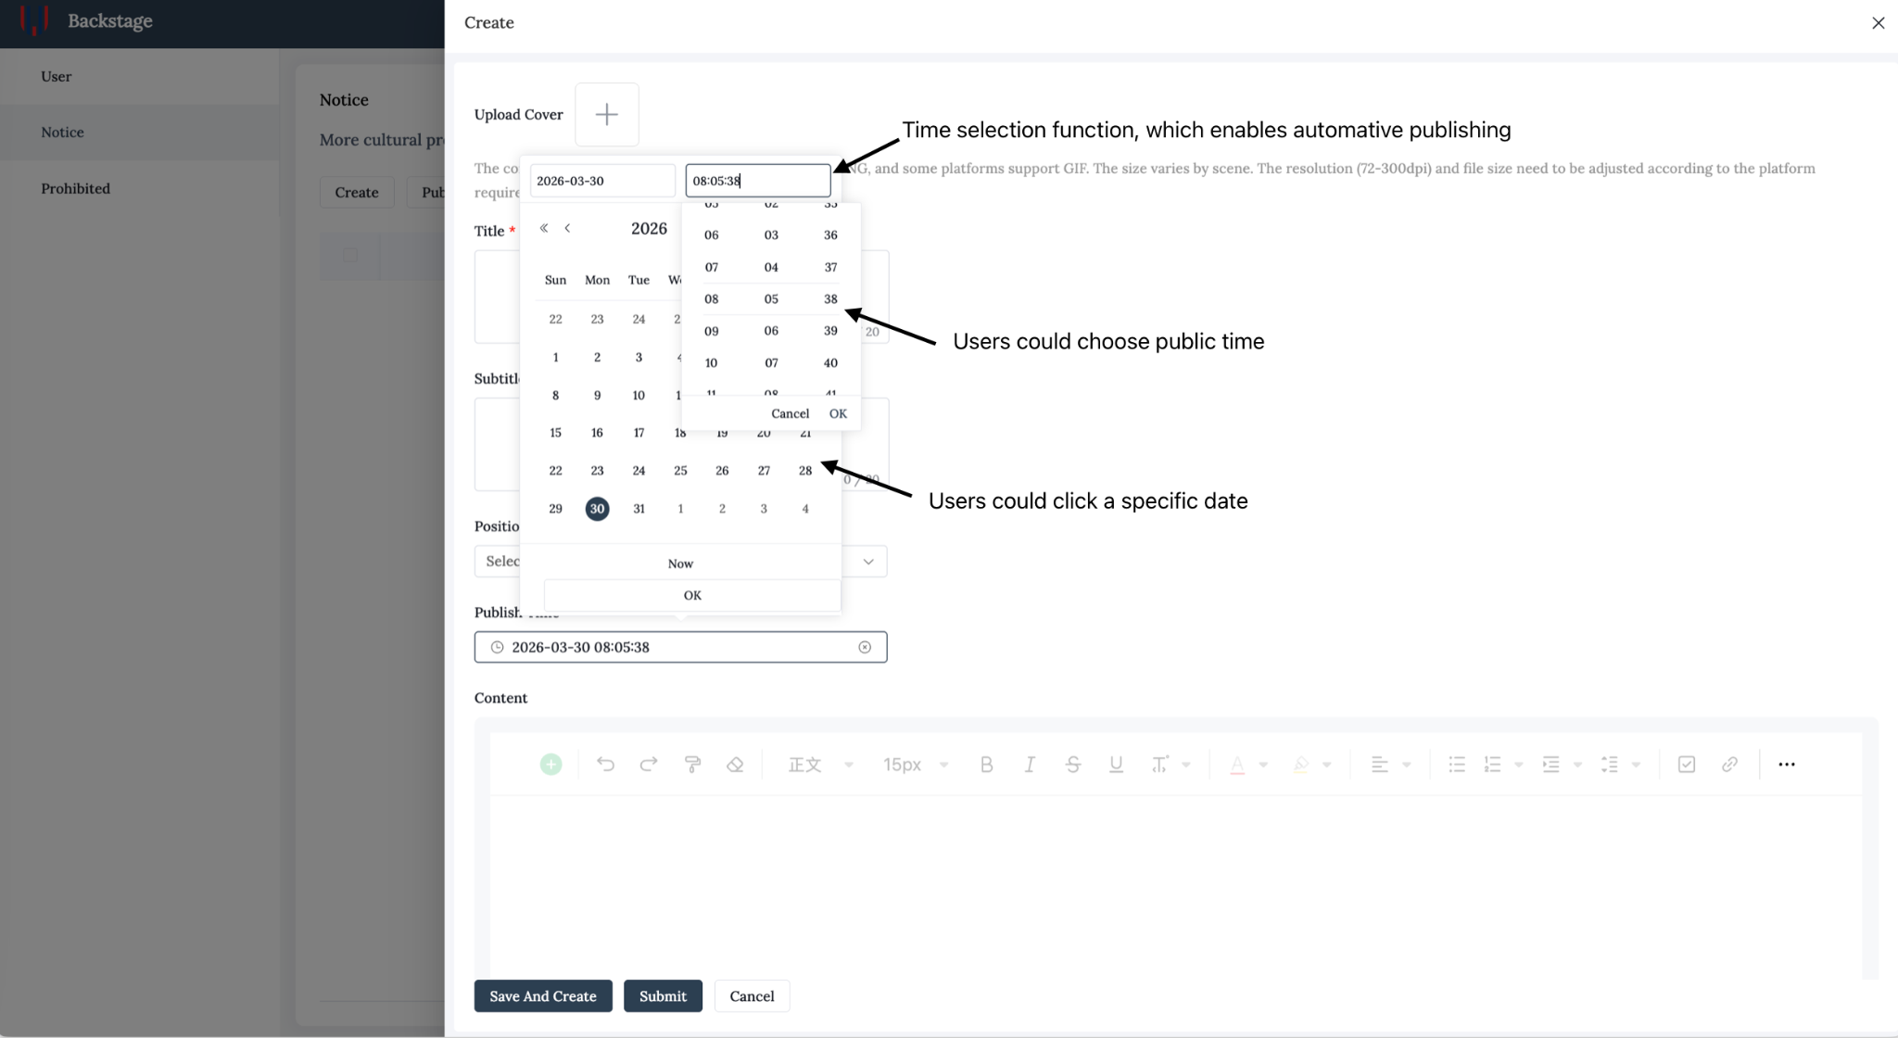

Fig. 2.3.1
Pseudocode for this function:
BEGIN Automated_Publishing_Module
Start module only when the backend server runs in runserver mode
Create a background thread
WHILE true DO
current_time <- get current timezone-aware system time
notice_list <- query database for notices
where status = Pending
and publish_time <= current_time
FOR each notice in notice_list DO
notice.status <- Published
save notice
ENDFOR
sleep for 30 seconds
ENDWHILE
END Automated_Publishing_Module

4. Community Interactive Module (Success Criterion 4)
- Wireframe of GUI: Discussion feed with comment cards and a text submission box.
- Function Description: DRF validates comment data; the backend verifies the JWT and stores the authenticated user's display name as author.
- Algorithm (Flowchart Logic): Student Submits -> Serializer Validation -> Attach Author Name -> SQL: INSERT Comment -> Refresh Feed.
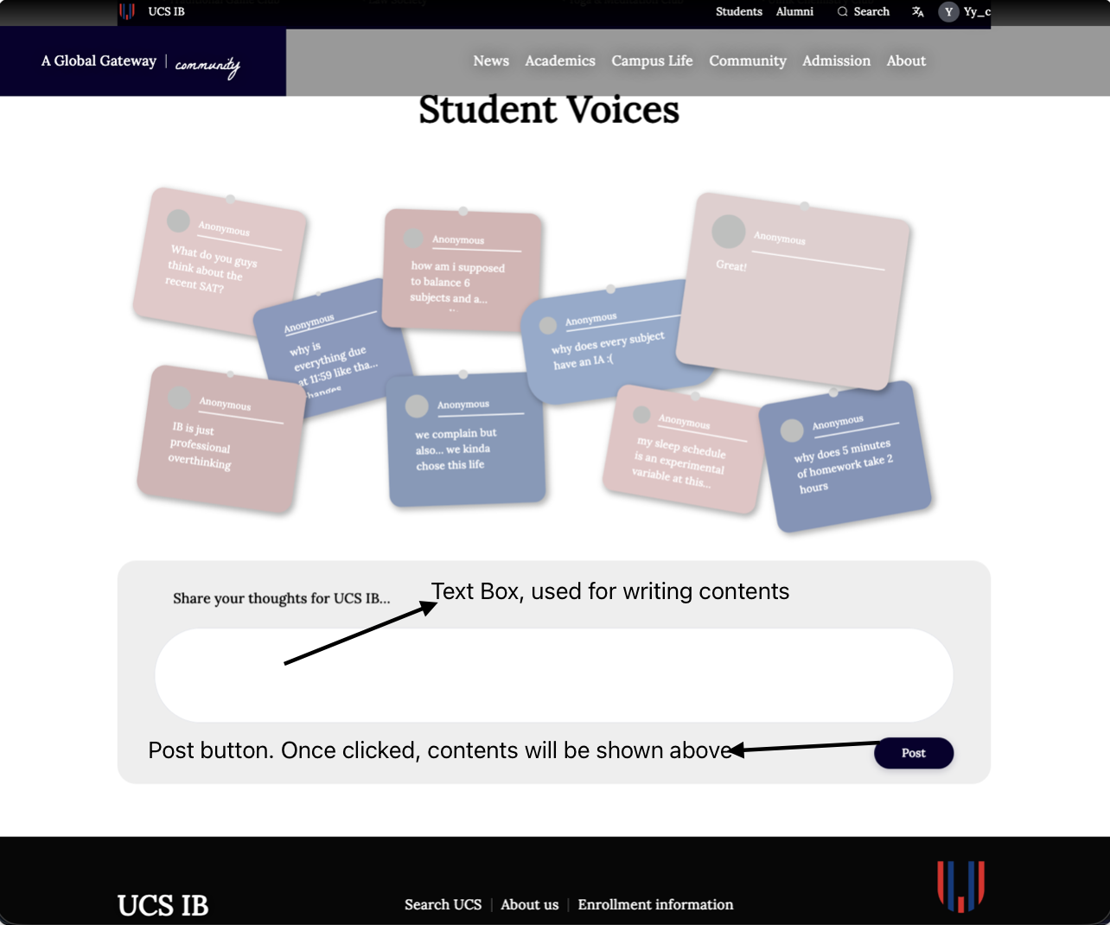
Fig. 2.4.1

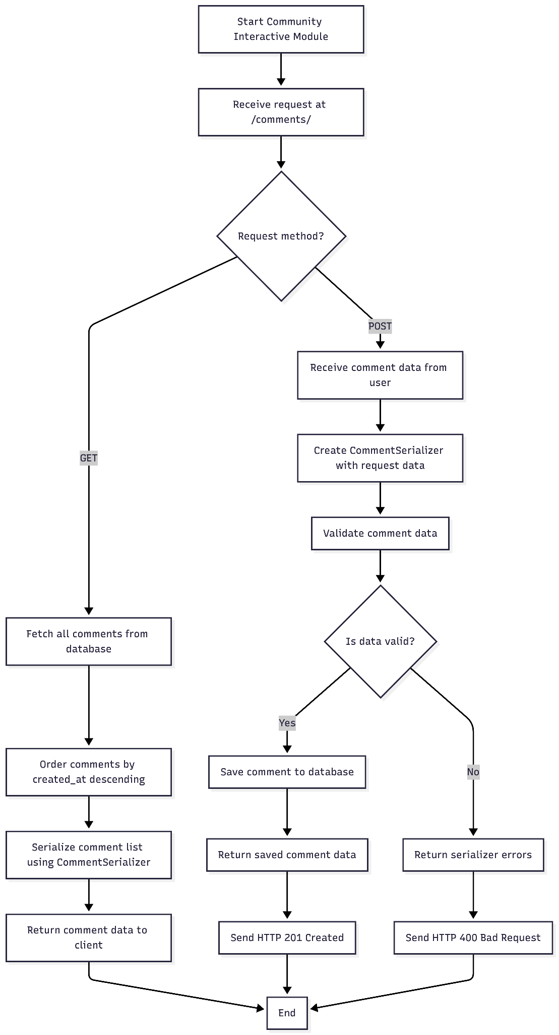
Fig. 2.4.2

5. Multi-Criteria Search Module (Success Criterion 5)
- Wireframe of GUI: Top search bar with a "Category" dropdown (News/Community).
- Function Description: Performs Fuzzy Search using SQL LIKE queries to find keywords in titles and content.
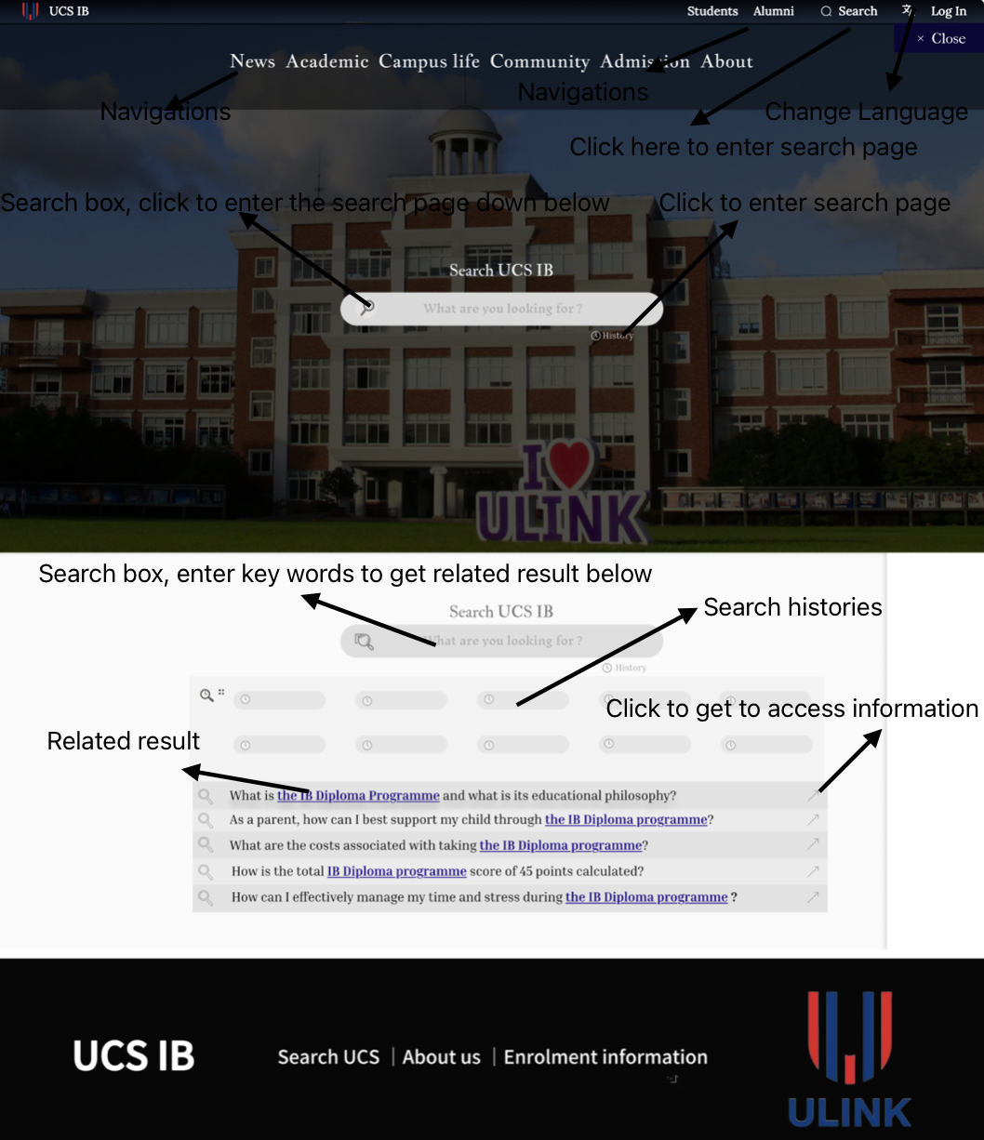

Fig. 2.5.1
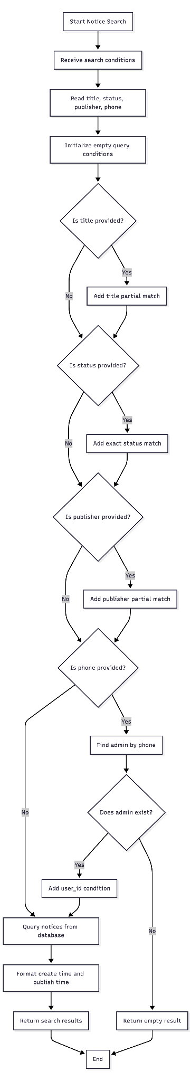
Fig. 2.5.2

6. Mobile Responsive Design (Success Criterion 6)
Responsive CSS media queries adapt the interface at widths of 575.98 pixels or below. Desktop navigation is replaced by a collapsible menu, multi-column content becomes full-width or vertical, and non-essential panels are hidden to prevent horizontal scrolling.
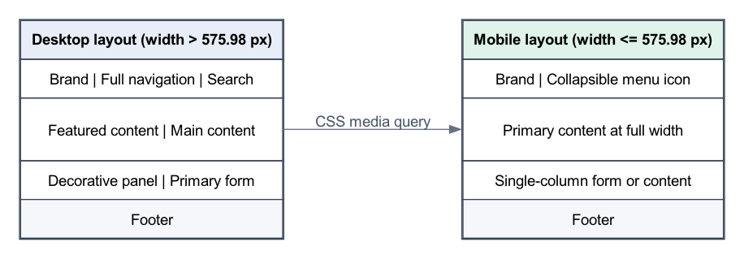
Fig. 2.6.1 Desktop and Mobile Layout Comparison
Element | Desktop design | Mobile design (<=575.98 px)
Navigation | Full horizontal menu and search | Collapsible menu; desktop search hidden
News | Featured area and notice list | Notice list expands to full width
Community | Side-by-side sections | Sections stack and images resize
Login | Decorative panel and form | Panel hidden; form uses full width

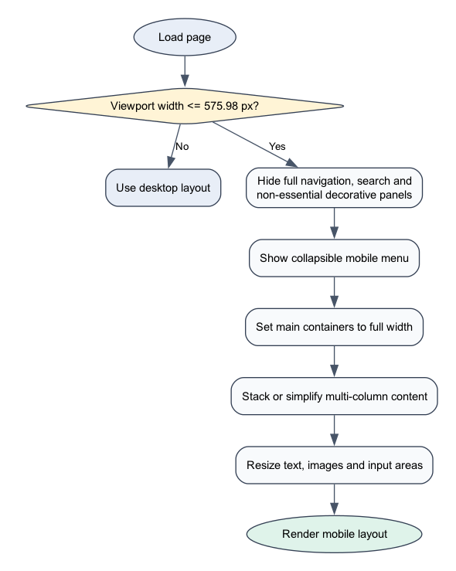
Fig. 2.6.2 Responsive Layout Decision Flow

3. UML Diagram

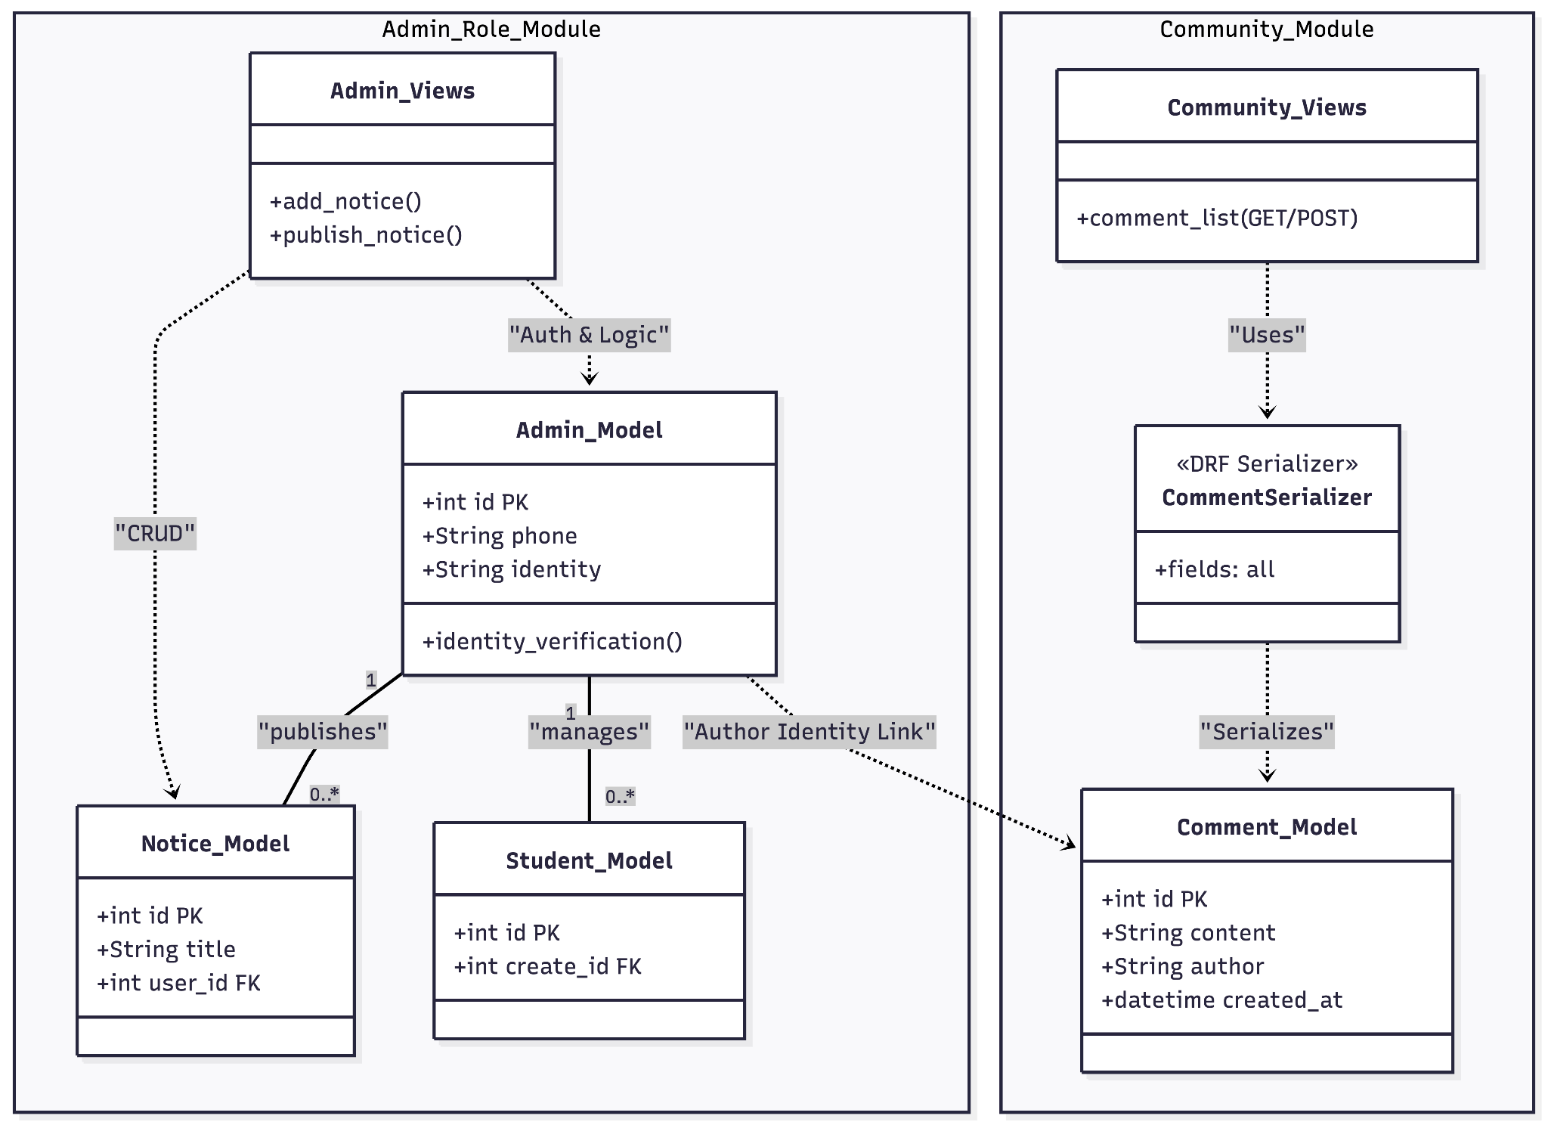
Fig. 3.1
Figure 3.1 maps request handlers to models and serializers. Notice ownership uses a database relationship, whereas comment identity is supplied from the authenticated JWT payload.

4. Testing Strategy

4.1 Methodology Description

Postman will simulate frontend API requests and verify JSON responses, HTTP status codes, JWT authorization and resulting MySQL changes for normal, boundary and invalid cases.

4.2 Representative Test Cases

4.2.1 User Authentication & Security (Related SC: #1)
Planned for execution through Postman

Test ID | Related SC | Test Data + Steps | Expected Result
T1 | #1 | Data: Username: miles_cai, Name: Miles, Phone: 13812345678, PW: SecurePass123, Confirm PW: SecurePass123.  Steps: Open Register page → Enter all details → Check "User Agreement" → Click Sign Up. | [Registration Case] New user record is created in the admin_role_admin table; Password is MD5 hashed for security; System redirects to the Sign-In page.
T2 | #1 | Data: Phone: 13812345678, PW: SecurePass123.  Steps: Open Sign-In page → Enter Phone and Password → Click Sign In. | [Login Case] System validates credentials; JWT Token is issued; User is redirected to the Dashboard; User name is displayed in the header.

4.2.2 Notice Management & CRUD (Related SC: #2)
Test ID | Related SC | Test Method | Expected Result
T3 | #2 | Create a notice with a .jpg cover image. | Image uploaded to Qiniu Cloud; Record saved in admin_notice_copy1.
T4 | #2 | Admin edits a notice title and clicks "Update". | DB updates immediately; Dashboard reflects new title.
T5 | #3 | Set notice publish_time to 1 min in future. | Asynchronous Thread auto-updates status to "Published" at the set time.

4.2.3 Community Comment Board (Related SC: #4)
Test ID | Related SC | Test Method | Expected Result
T6 | #4 | Student posts: "Is there a club meeting today?". | Comment saved in community_comment with the JWT-derived author name.
T7 | #4 | Attempt to post a comment with an empty string. | [Invalid Case] DRF returns 400 Bad Request; record blocked.
T8 | #1 | Student account attempts to access /admin_add. | [Security Case] Backend authorization blocks request; returns 403 Forbidden.

4.2.4 Global Search & Data Filtering (Related SC: #5)
Test ID | Related SC | Test Method | Expected Result
T9 | #5 | Search the keyword "Basketball" in "Announcements". | The system executes icontains query; lists all matching notices.
T10 | #5 | Search for a non-existent string "abc_123". | [Boundary Case] GUI displays "No results found" message.

4.2.5 T12-T13. Mobile Compatibility (Related SC: #6)

Test ID | Related SC | Test Method | Expected Result
T12 | #6 | Method: Use Chrome DevTools to simulate iPhone 14 screen width. | [UI Case] Navigation bar collapses into a "Hamburger Menu"; layout switches to a single-column view.
T13 | #6 | Method: Test "Sign In" button on a mobile touchscreen device. | [UX Case] Input fields and buttons are appropriately sized for touch interaction; text remains readable.

